CSE 3330-002

Project

Parts 1 & 2

Team 3: Anna Cox, Hedges Omordia, Diane Calderon

Part 1

EER schema diagram

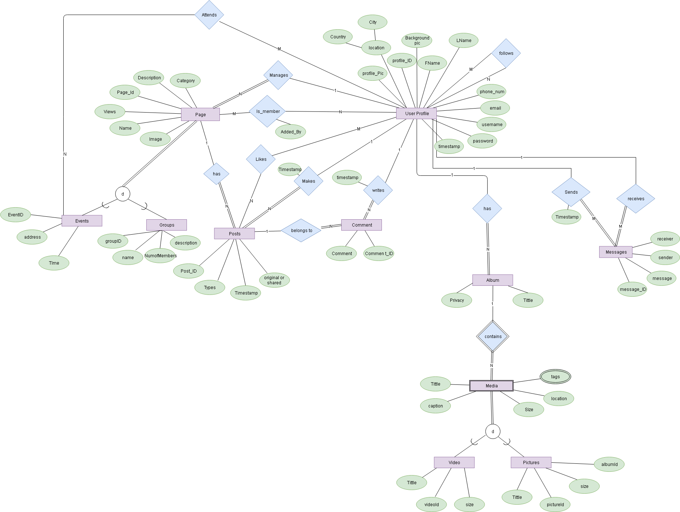

Design Choices

* A page is split into two types of entities, a group, and an event. We decided to have this distinction because a profile can have additional relationships with an event than with a group and there are also additional attributes that an event can have.
* There are two relationships a profile can have with an event, being a member, which means that they were invited to the event, and attends, meaning that they are going to the event
* A profile can have two types of relationship with a message, either the sender or the receiver, but for each message, a profile cannot be both the sender and receiver
* There has to be at least one profile to one page.

Missing or incomplete requirements

* It is assumed that all profiles are active within a page, so there is nothing explicitly stating that the profile is active.

Assumptions

* Every page will have at least one profile, but can have many.
* Each message will only have one receiver, and one sender. There are no group messages
* Each post and comment has only one author.
* Comments are allowed, but you cannot comment a comment.
* An event must have at least one profile but can be shared with other profiles.
* Profiles contain albums of pictures
* A page can be managed by only one profile
* There are two types of media, videos and pictures
* Profiles can follow other profiles
* A Page can be specialized into groups and events
* Profiles can attend events
* Profiles must be added to a page by creator
* A post can be shared, meaning that a profile, who is not the original creator, can post a copy of the post
* We allow as many users to join our website. Each user is identified by Profile_id
* Profiles can write(comment) on other pages
* Both creator and member profile can upload media. Each media file can be differentiated by attributes of its set. Creator has privilege to delete, and update files. Media entity set’s primary key is media_id

Part 2

Specifying the schema

CREATE TABLE GROUPS (

group_id int PRIMARY KEY,

name char(30) NOT NULL,

description char(100),

category char(30) NOT NULL,

views int,

image image?,

);

CREATE TABLE EVENTS (

event_id int PRIMARY KEY,

name char(30) NOT NULL,

description char(100),

category char(30) NOT NULL,

views int,

image image?,

Location varchar(50),

event_date date,

);

CREATE TABLE PROFILES (

profile_id int PRIMARY KEY,

Fname char(30) NOT NULL,

Lname char(30),

phone_num int,

email char(50) NOT NULL,

username char(30) NOT NULL,

password char(30) NOT NULL,

timestamp DATETIME,

country varchar(30),

city varchar(30),

profile_photo int,

cover_photo,

FOREIGN KEY profile_photo REFERENCES MEDIA(media_id),

FOREIGN KEY cover_photo REFERENCES MEDIA(media_id)

);

CREATE TABLE COMMENTS (

comment_id int PRIMARY KEY,

comment char(150),

Timestamp DATETIME,

profile_id int NOT NULL,

post _id int NOT NULL,

FOREIGN KEY profile_id REFERENCES Profile(profile_id),

FOREIGN KEY post_id REFERENCES Post(Post_id),

);

CREATE TABLE MEMBERS (

group_id int NOT NULL,

profile_id int NOT NULL,

added_by int,

admin boolean NOT NULL,

PRIMARY KEY (page_id, profile_id),

FOREIGN KEY group_id REFERENCES GROUPS(group_id) ON DELETE CASCADE,

FOREIGN KEY profile_id REFERENCES PROFILES(profile_id) ON DELETE CASCADE,

FOREIGN KEY added_by REFERENCES PROFILES(profile_id)

);

CREATE TABLE POSTS (

post_id int PRIMARY KEY,

timestamp DATETIME NOT NULL,

original BOOLEAN,

profile_id NOT NULL,

type NOT NULL,

FOREIGN KEY profile_id REFERENCES PROFILES(profile_id),

);

CREATE TABLE MESSAGES (

message_id int PRIMARY KEY,

timestamp DATETIME NOT NULL,

sender int NOT NULL,

Receiver int NOT NULL,

Message VARCHAR(256),

FOREIGN KEY sender REFERENCES PROFILES(profile_id),

FOREIGN KEY receiver REFERENCES PROFILES(profile_id)

);

CREATE TABLE INVITED (

event_id int NOT NULL,

profile_id int NOT NULL,

Invited_by int,

admin boolean NOT NULL,

PRIMARY KEY (event_id, profile_id),

FOREIGN KEY event_id REFERENCES EVENTS(event_id),

FOREIGN KEY profile_id REFERENCES PROFILES(profile_id),

FOREIGN KEY invited_by REFERENCES PROFILES(profile_id)

);

CREATE TABLE LIKES(

post_id int NOT NULL,

profile_id int NOT NULL,

PRIMARY KEY (post_id, profile_id),

FOREIGN KEY post_id REFERENCES POSTS(post_id),

FOREIGN KEY profile_id REFERENCES PROFILES(profile_id),

);

CREATE TABLE EVENT_POSTS (

event_id int NOT NULL,

post_id int NOT NULL,

PRIMARY KEY (event_id, post_id),

FOREIGN KEY event_id REFERENCES EVENTS(event_id) ON DELETE CASCADE,

FOREIGN KEY post_id REFERENCES POSTS(post_id),

);

CREATE TABLE GROUP_POSTS (

group_id int NOT NULL,

post_id int NOT NULL,

PRIMARY KEY (event_id, post_id),

FOREIGN KEY event_id REFERENCES GROUPS(group_id) ON DELETE CASCADE,

FOREIGN KEY post_id REFERENCES POSTS(post_id) ,

);

CREATE TABLE ALBUMS (

title varchar(40) NOT NULL,

profile_id int NOT NULL,

album_id int PRIMARY KEY,

privacy varchar(15),

FOREIGN KEY profile_id REFERENCES PROFILES(profile_id) ON DELETE CASCADE,

);

CREATE TABLE MEDIA (

media_id int PRIMARY KEY,

album_id int NOT NULL,

type varchar(20),

caption varchar(256),

size int NOT NULL,

location varchar(30),

FOREIGN KEY album_id REFERENCES ALBUMS(album_id)

);

CREATE TABLE MEDIA_TAGS (

media_id int NOT NULL,

tag varchar(30) NOT NULL,

PRIMARY KEY (media_id, tag),

FOREIGN KEY media_id REFERENCES MEDIA(media_id) ON DELETE CASCADE

);

CREATE TABLE EVENT_ATTENDEES (

event_id int NOT NULL,

attendee int NOT NULL,

PRIMARY KEY (event_id, attendee),

FOREIGN KEY event_id REFERENCES EVENTS(event_id) ON DELETE CASCADE,

FOREIGN KEY attendee REFERENCES PROFILES(profile_id) ON DELETE CASCADE

);

CREATE TABLE FOLLOWERS (

follower int NOT NULL,

following int NOT NULL,

PRIMARY KEY (follower, following),

FOREIGN KEY follower REFERENCES PROFILES(profile_id) ON DELETE CASCADE,

FOREIGN KEY following REFERENCES PROFILES(profile_id) ON DELETE CASCADE

);

Mapping Choices

* For mapping the specialization of PAGE into EVENTS and GROUPS, it was chosen that each subclass has its own entity, because profiles have an additional relationship with EVENTS, which has its own entity, and references EVENTS, but not groups. It was not necessary to have PAGE with its own entity.
* The sends and receives relationship between MESSAGE and PROFILE can be represented by only one relation, MESSAGE, indicating both the sender and receiver

Schemas

